Custom Tab for Microsoft Teams

This document contains guide lines that followed POC works for adding Custom Tab in Microsoft Teams. App experiences in Teams are defined by their app manifest, and bundled in an app package(.zip) for use in side loading or Office Store submission.

Tools used

1. Visual Studio 2017

Steps

1. Create App package (.zip package)
2. Create Web Application
3. Load package into a Team
4. Access and add a new Tab to your Team

**1. Create App package**

A Teams app package is a .zip file containing:

* A manifest file named "manifest.json" - Specifies attributes of your app and points to required resources for your experience, such the location of its tab configuration page
* A transparent "outline" icon and a full "color" icon

You can download Full App package from below location and customize as required.

<https://github.com/OfficeDev/Microsoft-teams-docs/blob/master/teams/FullAppPackage.zip>

**2. Create Web Application**

Web application will be used to host the page, which will capture user information while Tab adding process. In the manifest file, you will set this page url.

**Note : You must host your page on a secure HTTPS endpoint, ensure that your page permits itself to be iframed, include the Microsoft Teams JavaScript library, and call microsoftTeams.initialize().**

**Refer Appendix section for a sample Page developed.**

**3. Load package into a Team**

1. Open Microsoft Teams and create/edit a team

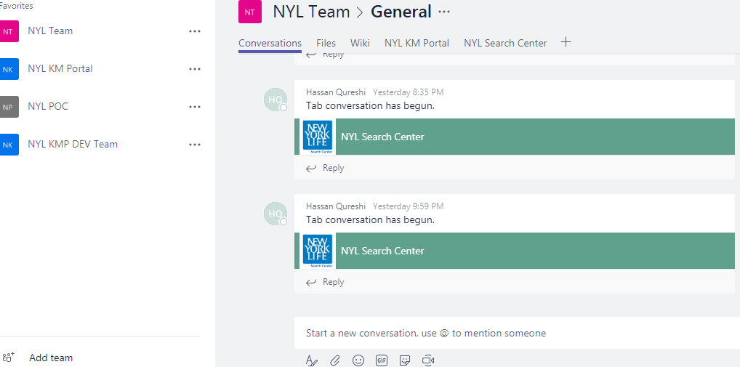

1. Choose More options (⋯) and choose **Manage team**.

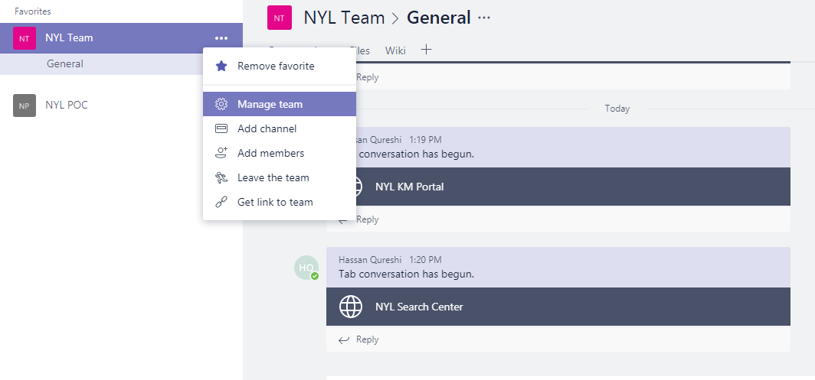

1. Manage Team Option will navigate to the page Team dashboard.

There selects the tab named **Bots.**

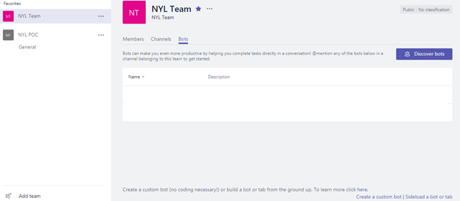

1. Then select the **Side load a bot or tab**

**Note: For sideloading to work, your tenant admin must first enable sideloading of apps.**

Refer following article for enabling sideloading of apps for Microsoft Teams:

<https://msdn.microsoft.com/en-us/microsoft-teams/setup#3-enable-sideloading-of-apps-for-microsoft-teams>

1. Select the folder path which has the .zip package.
2. Upload the package to the Team.

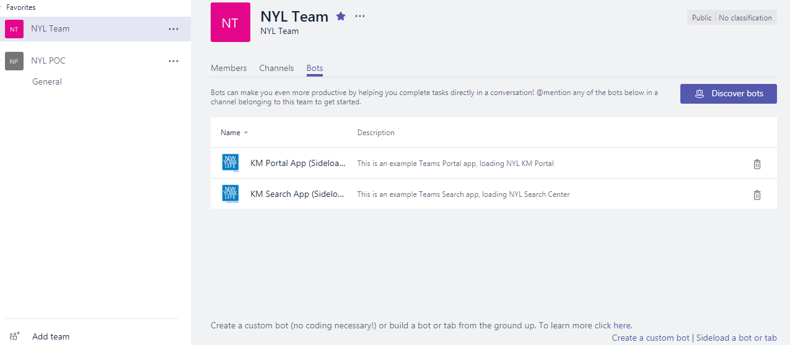

1. Uploaded packages are available on the Microsoft Teams dashboard.



1. **Access and add a new Tab to your Team**
2. Click the (+) sign

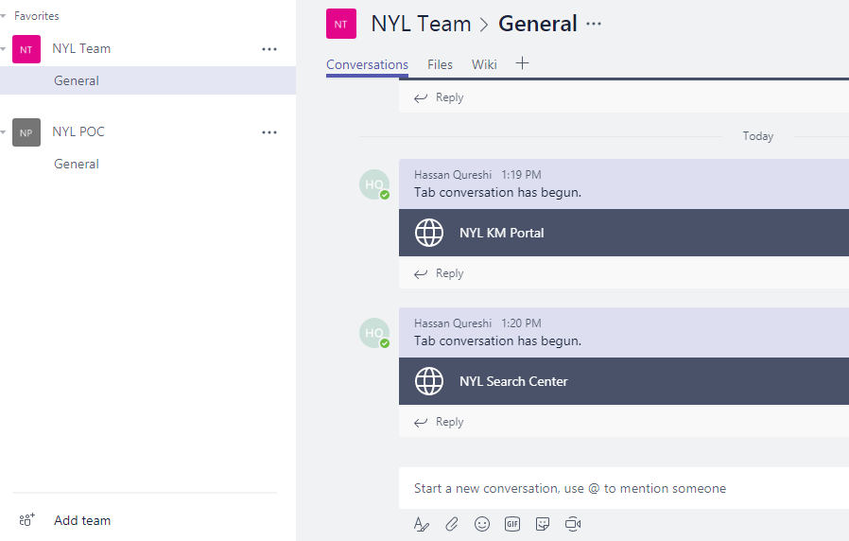

1. Custom Tabs are displayed in the Microsoft Teams.

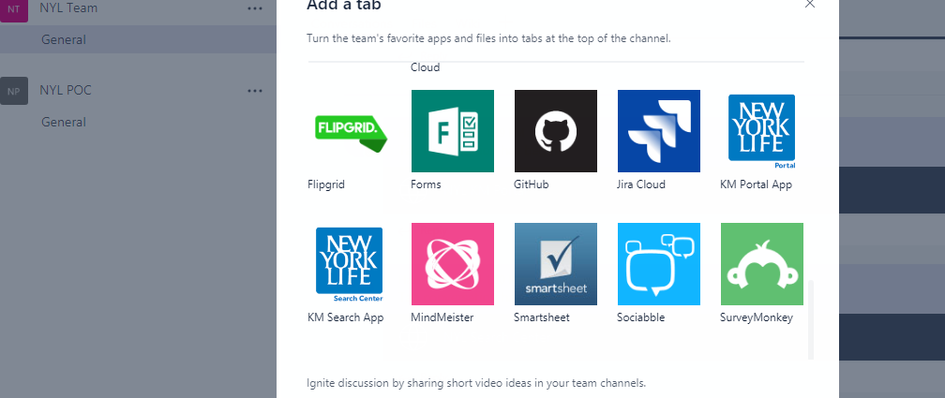

1. Select the app and save it.

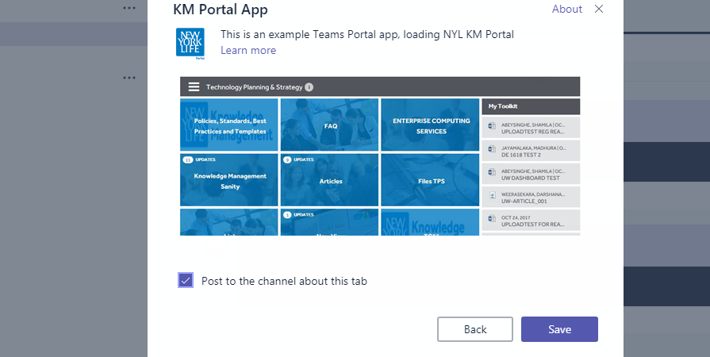

1. Tabs has been deployed into the Microsoft Teams.

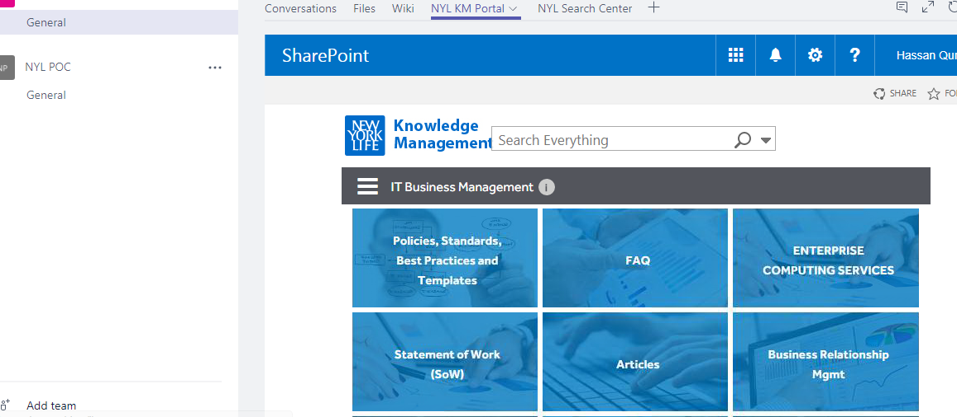

**References:**

<https://msdn.microsoft.com/en-us/microsoft-teams/sideload>

<https://msdn.microsoft.com/en-us/microsoft-teams/createpackage>

<https://msdn.microsoft.com/en-us/microsoft-teams/prerequisites>

<https://msdn.microsoft.com/en-us/Microsoft-teams/createconfigpage>

**Appendix:**

Sample Tab page

<!DOCTYPE html>

<html>

<head>

<meta name="X-FRAME-OPTIONS" content="ALLOW-FROM https://teams.microsoft.com/" />

</head>

<body>

<div>

<label>Project ID</label>

<input type="text" id="TextBoxProjectID" name="TextBoxProjectID" maxlength="255" placeholder="">

<div>

<img src="../../Images/search-center.png" />

</div>

</div>

<script src="https://statics.teams.microsoft.com/sdk/v1.0/js/MicrosoftTeams.min.js"></script>

<script type="text/javascript">

microsoftTeams.initialize();

microsoftTeams.settings.setValidityState(true);

microsoftTeams.settings.registerOnSaveHandler(function(saveEvent){

var projectID = document.getElementById("TextBoxProjectID").value;

projectID = (projectID === "") ? "*" : projectID;

//console.log(projectID);

microsoftTeams.settings.setSettings({

entityId: "searchcenter",

contentUrl: "https://nylonline.sharepoint.com/sites/SearchCenter/pages/EverythingResults.aspx?k=" + projectID,

suggestedDisplayName: "NYL Search Center",

websiteUrl: "https://nylonline.sharepoint.com/sites/SearchCenter/pages/EverythingResults.aspx?k=" + projectID

});

saveEvent.notifySuccess();

});

</script>

</body>

</html>